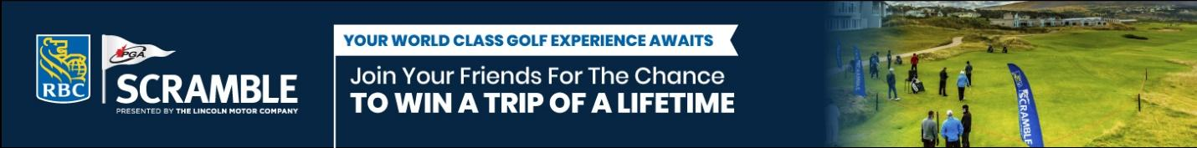

Good Morning/Afternoon,
Have you heard about the RBC PGA Scramble presented by the Lincoln Motor Company?
Our club will be hosting a local qualifier on (enter date here). There is an entry fee of $29.95 (+ tax) per person to compete in this qualifier and be a part of the RBC PGA Scramble presented by The Lincoln Motor Company.
The RBC PGA Scramble presented by The Lincoln Motor Company is a national series of events taking place at more than 175 golf facilities around the country in 2019, culminating with Regional Finals and the RBC PGA Scramble presented by The Lincoln Motor Company National Championship in October.
The series of events draws thousands of amateur golfers—who will form their own team of four players— from across the country. Teams will look to make it through local and regional qualifiers with the ultimate goal of playing in the National Championship in October at Cabot Links and Cabot Cliffs! Not only do you get the opportunity of competing with three of your closest friends, but you will also play alongside a PGA of Canada Professional at the Regional and National levels.
This is one program where anyone can play and anyone can win! Check out this video from last year.
Speak with (insert name here/PGA of Canada Professional) about this fun opportunity.
To get your team registered right now, click here (insert hyperlink to registration page). The registration deadline closes on (insert date—1 week prior to event date).

Additional information for the RBC PGA Scramble presented by The Lincoln Motor Company can be found here.
We look forward to seeing you,
(Insert Name Here)

